Table S2. The demographics from the pilot cohort (n=10).
 | Term  (n=5) | Preterm  (n=5) | p value
Age | 34.8 | 34.0 | 0.79
Gestational age at delivery | 31.7 | 39 | p < 0.01
Birth weight | 2055 | 3230 | p < 0.05
BMI at delivery | 28.1 | 23.5 | p < 0.01

Table S3. Primer set for pyrosequencing designed by the PSQ Assay Design software.
Target ID |  | F1 | R1 | S1 | TM  (F) | TM  ('R)
cg04481923 | Pos1 | GTAAAGTTAAAAGGGATAAAAAA | AACTTTCTATCTATCCATCTCTAT | ATAAAAGGGTTAGTAAGTAT | 60.1 | 58.5

Table S4. Primers sets for Quantitative real-time PCR.
Target ID | F1 | R1 | TM  (F) | TM  ('R)
VTRNA2-1 | CACACCTTCAAAGTGACACCA | TCCTCACGGACTTTCTA | 67.1 | 65.8

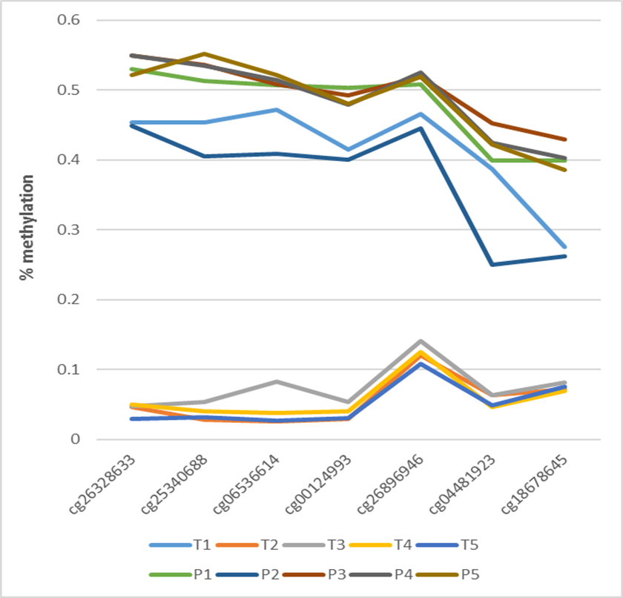

Figure S1. Comparison of seven differential CpG sites on VTRNA2-1
between women with term and preterm births in initial samples (n=10).

